Sentence tokenizer 🡪 Sentence tokenization is **the process of splitting text into individual sentences**. nltk.sent_tokenize(data)

Word tokenizer 🡪 Sentence tokenization is **the process of splitting text into individual sentences**. nltk.word_tokenize(data)

Parts of Speech tags 🡪 nltk.pos_tag()

Stopwords 🡪 stopwords.words(‘language’)

Punctuation 🡪 string.punctuation

**Stemming 🡪 will simply chop up the words (e,es,ing etc)**

1. Porter Stemmer
2. Lancaster Stemmer
3. Snowball Stemmer

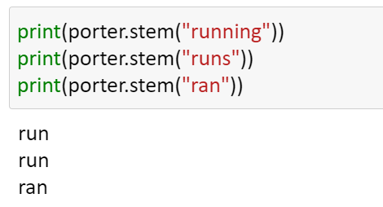

**Lemmatization 🡪**

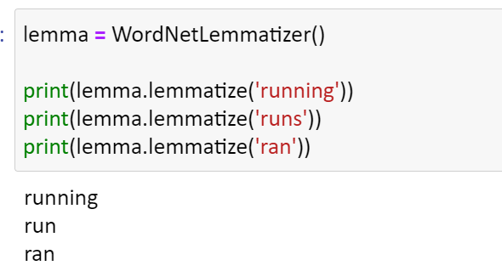

Named Entity Recognition(NER)

# **Tf-Idf (Term frequency–Inverse document frequency)**

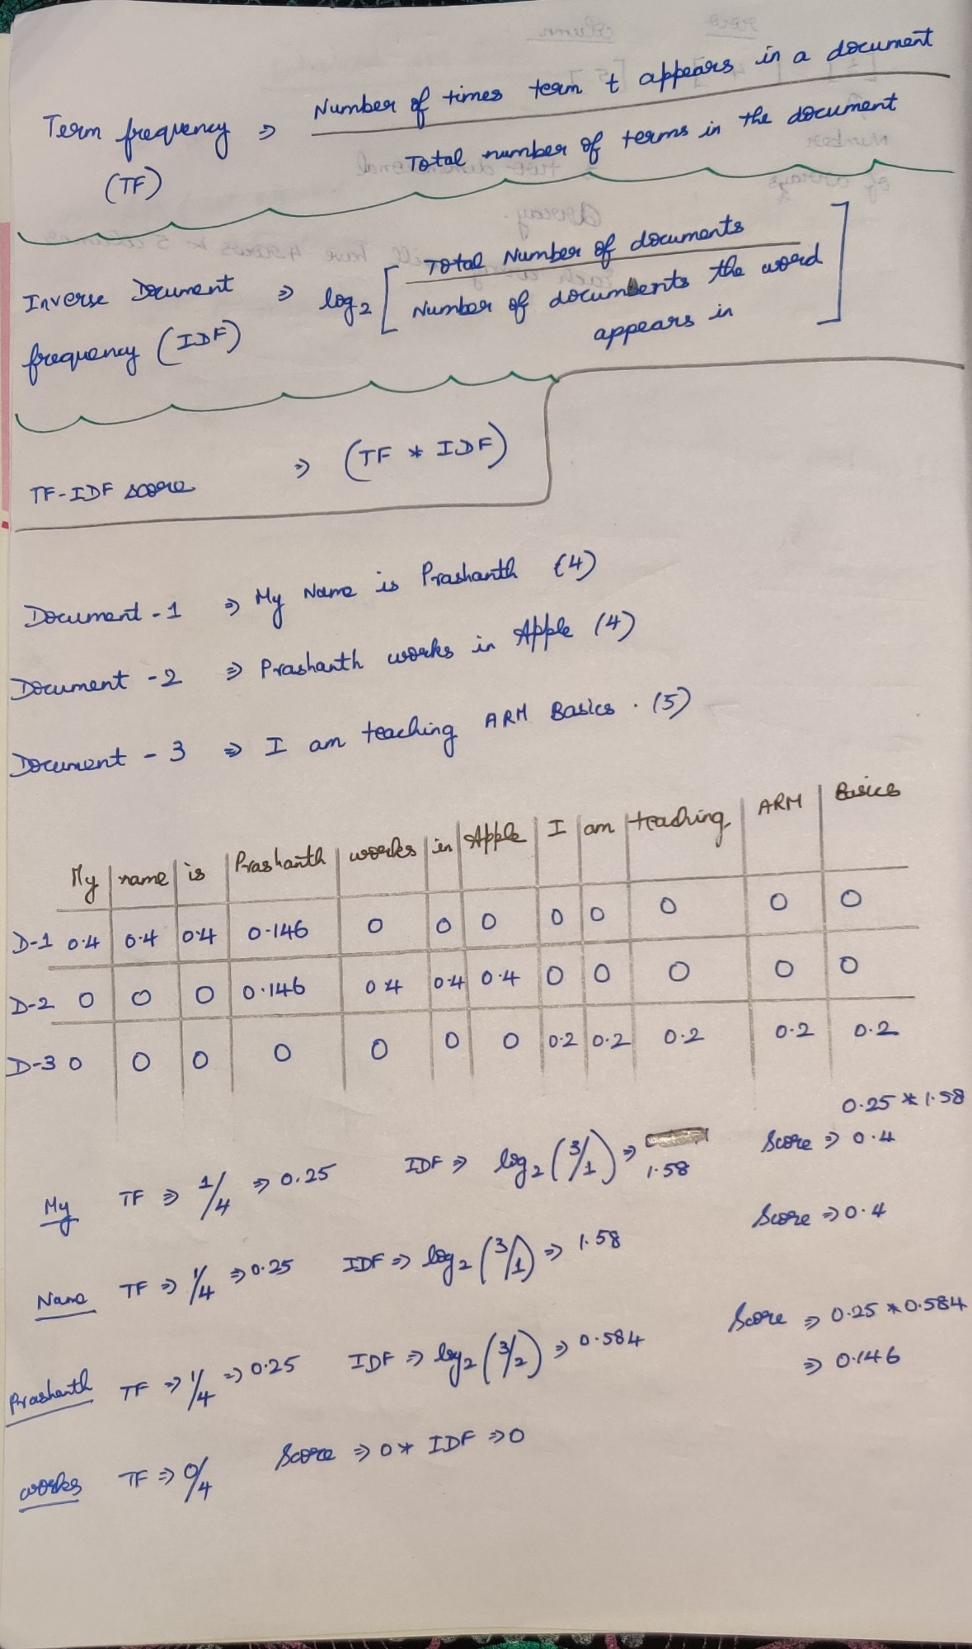

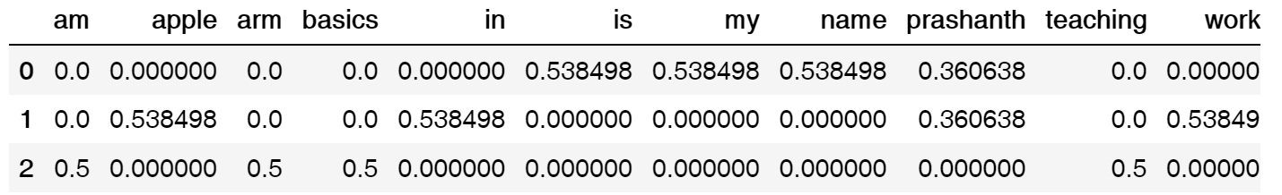

The above table is only correct

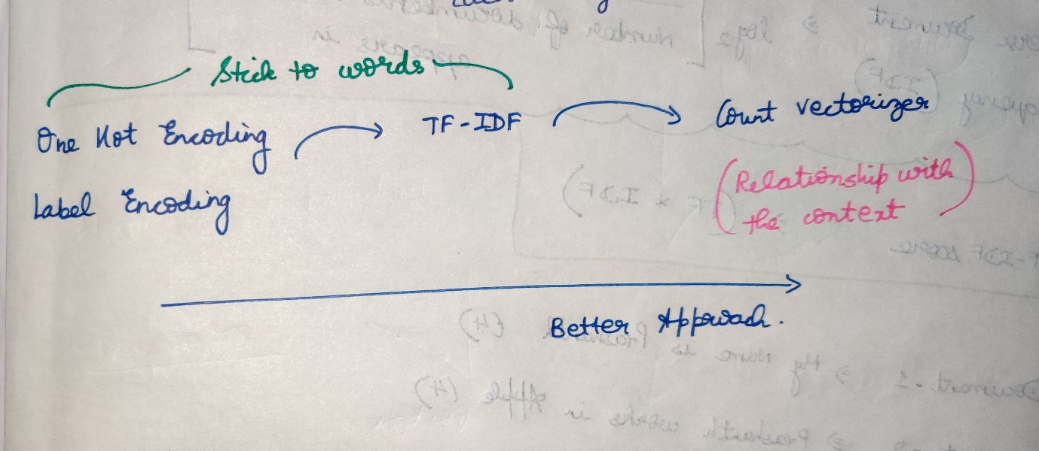

TF-IDF simply focuses on a particular word.  
It never understands the contextual meaning like how one word is related to other.

To over-come Count vectorization comes into picture

# **Count Vectorization**

## Bag of Words

## N-gram Model

In bigram and multigram, there exists a relationship between previous text and the next text.

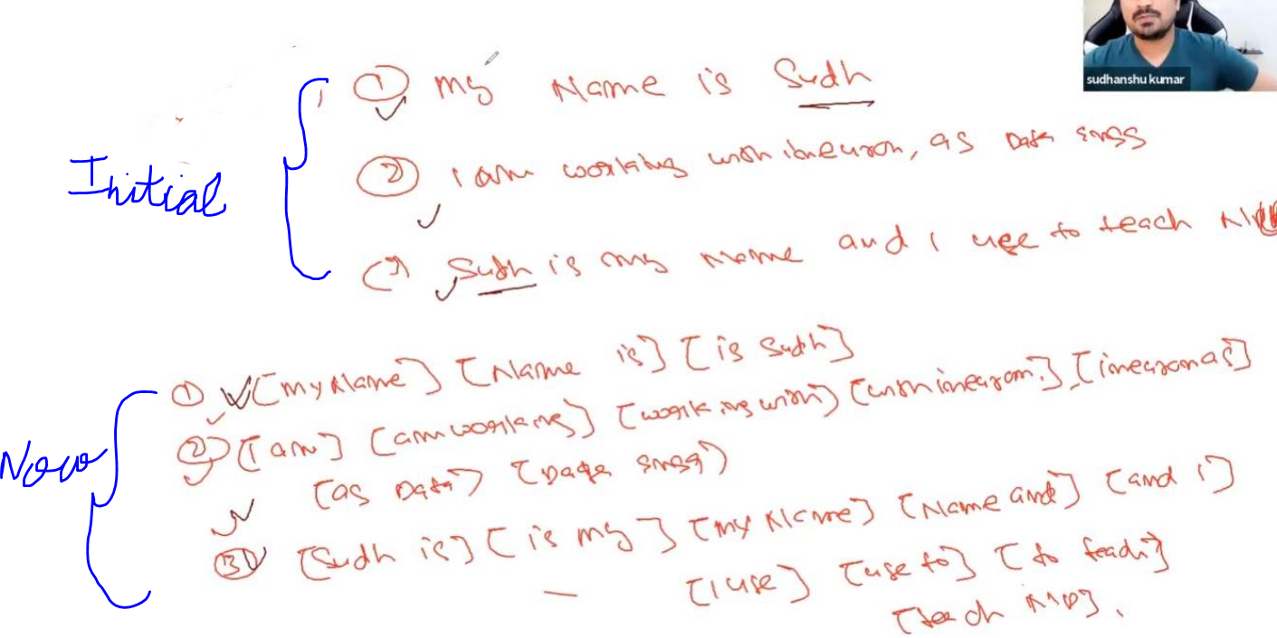

Initial 🡪 Sudhanshu is repeated twice  
Now 🡪 [is Sudhanshu] and [Sudhanshu is] repeated only once.

